- What is the population, sample, and variable in the following scenarios?
  - Hershey measures the weight of 3000 bags of chocolate kisses.

  - In a study on leukemia, a research team gives 64 patients a trial drug.

- An ecology team catches 25 wolves, tags them, and releases them back into their habitat. A month later, they return and catch 16 wolves, 10 of which are tagged. How many wolves are in the total population?

- 0 0 1 1 5 5 5
1 1 3 6 7 8
2 0 1 3 3 3 6 7
3 2 3 5 5 7 9
4 3 4 8
5 4

What is the median for the data above? The mode?

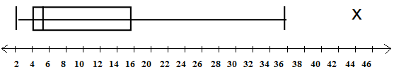
- Given the box and whisker plot showing inches of rain last month, answer the following questions.
  - Between what values is the middle 50% of the data?
  - What percent of the data is between 2 and 4 inches of rain?
  - Where is the max of this data set?

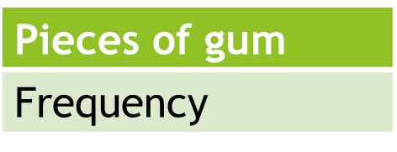
- The following frequency table shows the number of pieces of gum chewed in a week.

  - What is the median of the data?
  - What is the relative frequency of 3 pieces of gum?
  - What percentile is 1 piece of gum?
  - What is the 80th percentile?

- 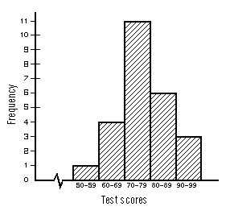
  - Approximate is the median of the data in the histogram above.
  - What is the percentile of a score of 83? (hint: 83 is in the 80-89 interval)

- The amount of M&Ms in a 5 lb bag of peanut butter M&Ms follows the distribution N(5, .15).
  - Construct a bell curve and use it to answer the following questions.

  - 95% of bags of M&Ms are between what weights?
  - What weight would a bag at the 97.5th percentile be?
  - What weights are in the upper 16% of data?
  - What percent of bags are between 4.7 lbs and 5.15 lbs?

- The math SAT scores for males is N(532, 119).
  - What percent of males scored between a 500 and 600?
  - What percent of males scored above a 700?

- The reading SAT scores for females is N(493, 112)
  - What percentile is a female who scored a 600?
  - What is the score of a female who scored in the 80th percentile?
  - What range of scores is in the middle 65% of the data?

