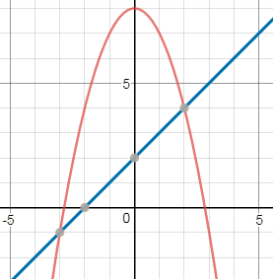

g(x)

Use the graph to the right to answer the following questions.

1. f(1) =

2. g(-1) =

3. When does f(x) = g(x)?

4. When is f(x) > g(x)?

5. When is f(x) < g(x)?

6. Find x when g(x) = 6.

f(x)

7. Find x when f(x) = -3

8. Which is greater: f(3) or g(0)

* Domain: _________________________
* Range: ___________________________
* Maximum: _______________________
* Minimum: ________________________
* Rel. Max: _________________________
* Rel. Min: _________________________
* Increasing Interval: ________________
* Decreasing Interval: _______________
* X-intercepts: ______________________
* Y-intercepts: ______________________

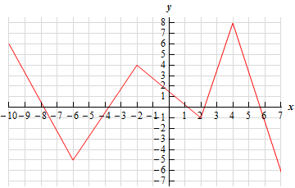Use the graph below to answer the following:

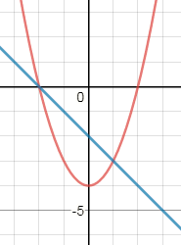

g(x)

Use the graph to the right to answer the following questions.

1. f(1) =

3. When does f(x) = g(x)?

4. When is f(x) > g(x)?

2. g(-1) =

5. When is f(x) < g(x)?

6. Find x when g(x) = 2.

f(x)

7. Find x when f(x) = -5

8. Which is greater: f(2) or g(-2)

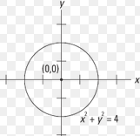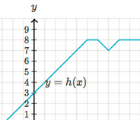**Are the following functions?**

1. 2. 3.

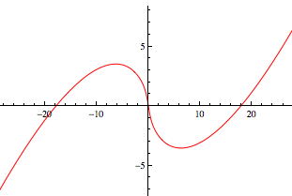

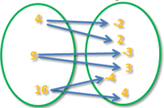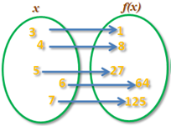

4. 5.

6. { (2, 4), (3, -5), (6, 4), (-2, 9)}





Use the graph above to answer the following:

1. f(x) = 20 2. f(x) = 16 3. f(12) = 4 f(x) = 8