Foundations of Math 1
Writing Linear and Exponential Equations Review Worksheet

Write an appropriate equation for each function graphed below.
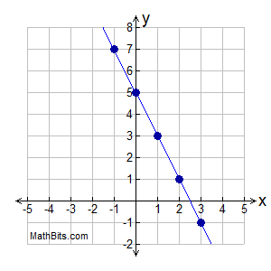
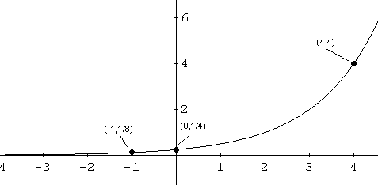

Find the exponential equation that passes through the following points.

3. (1,3) and (3, 27) 4. (1,6) and (4, 162)

Find the linear equation in slope-intercept form that passes through the following points.

5. (15, -10) and (20, -6) 6. (3, -2) and (7, 10)

Answer the following questions given the equation.
7. y = 6(3.65)^{x} 8. y=(.22)^{x}
a. Initial Value: ________ a. Initial Value: ________
b. Growth/Decay Factor:______ b. Growth/Decay Factor: ________
c. Rate of Growth/Decay:______ c. Rate of Growth/Decay: ________
Answer using your algebra knowledge.
9. A new car that sells for $18,000 depreciates by a constant rate each year. After three years the car is worth $7593.75.
- Does the problem represent growth or decay? b. What is the growth/decay factor?

- Write an exponential equation. d. By what percent is the depreciating?

- When will the car be worth $5000? f. What is an appropriate Domain?

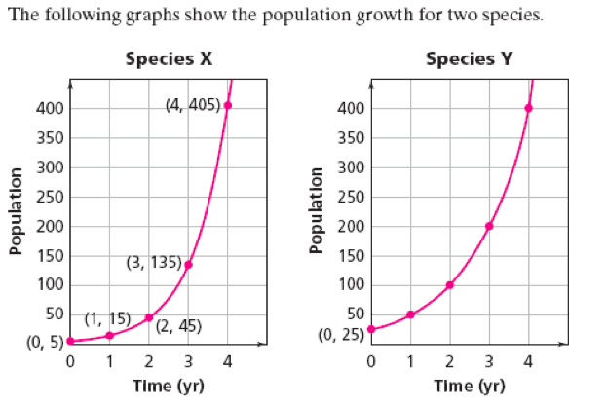
10.

a. Find the growth factors for the two species. Which species is growing faster? Explain.

b. What are the y-intercepts of the graphs of Species X and Species Y? Explain what these y-intercepts tell you about the populations.

c. Write the equation that describes the growth of Species X.

d. Write the equation that describes the growth of Species Y.

- What is an appropriate domain for these species?

