$$f(x)$$ | $$g(x)$$ | $$h(x)$$
$$f\left(x\right)=3x-5$$ | $$x$$ $$g(x)$$  -7 12  -3 8  -1 6  1 2  3 -4 | 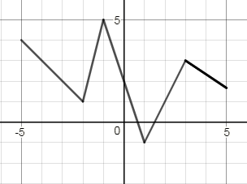
Foundations of Math 1 Name __________________________________
Worksheet 3.6

1. $f\left(2\right)=$ 2. $h(-3)$= 3. $g\left(-7\right)=$

4. $f\left(-1\right)=$ 5. $h(2)$= 6. $g\left(-3\right)=$

7. $f\left(3\right)=$ 8. $g\left(1\right)=$ 9. $h(3)$=

10. $g\left(x\right)= 6$ 11. $h(x)$= 3 12. $f\left(0\right)=$

13. $g\left(x\right)= 2$ 14. $h\left(x\right)=-1$ 15. $f\left(x\right)=$ 7

16. $g\left(x\right)=12$

